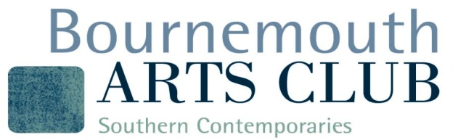
Bournemouth Arts Club Selection Criteria

What we are looking for?

We are looking for members with a serious commitment to their work and akeen interest in the visual arts, and who are also keen to participate in Clubactivities.

Candidates should be familiar with the history, ethos and standards ofBournemouth Arts Club/Southern Contemporaries and should haveattended our recent exhibitions.

At selection, candidates should bring a maximum of three pieces of recentwork, including at least one finished or framed to exhibition standard, plusone ‘work in progress’. If appropriate, sketchbooks, photographs and otherpreliminary materials should also be included.

Candidates should be able to explain and discuss their work and the ideasbehind it in a meaningful way. They will be asked to outline their presentartistic intentions and objectives, their level of commitment to their workand the motivation behind it.

The selectors are looking for:
- Evidence of rigorous self-evaluation and critical appraisal
- Innovation, exploration, and experimentation with different ways ofworking, not settling comfortably into what they can already do.
- The ability to interpret things in a personal and original way, notrelying on stereotype subjects or styles of working which have acommonplace appeal.

The selectors’ decision is final. Unsuccessful candidates areencouraged to continue asAssociate Members, join in with Clubevents, and apply again in 12 month’s time.

If you are worried about the selection process, please speak to the Chair (Adam Liddell adamliddell39@gmail.com), or to any FullMember about their own experience.

22 January 2024

